Craft Stick Bridge

Subject: Physics, Math  Related Subjects: Civil Engineering | Grade Level(s): 6th and 7th  Length of Lesson: 70 Minutes | Type: Project  Keywords: Load, Bridge, structure

Lesson Overview
Create a craft stick bridge that supports the most weight in a bucket.

Lesson Focus
Students will centrally focus on load distribution and how triangles are the most efficient shapes to carry loads.

Lesson Objective(s) | By the end of this lesson, students will learn -  - Build a bridge that can hold the most weight while meeting specific criteria. This activity helps students understand structural engineering and load-bearing principles.  - By designing and constructing their own bridges, students learn about the importance of shapes, materials, and construction techniques in creating strong and stable structures.

Lesson Timing

5 minutes | Introduce the Lesson
10 minutes | Review Bridge Designs and Construction Rules
5 minutes | Group Planning and Sketching
30 minutes | Bridge Construction
10 minutes | Bridge Testing (Weight Challenge)
10 minutes | Reflection, Discussion, and Wrap-Up

Materials | - Craft sticks  - Hot glue  - Hot glue gun  - Bucket  - Rocks for weights  - Rulers  - Scale
Instructor Prep | - Prep about different types of bridges and different designs
Related Resources | - Popsicle Stick Bridge : 9 Steps (with Pictures) - Instructables  - Popsicle stick bridge

Lesson Plan

Introduction
There are numerous ways to construct bridges, both real ones and those made from popsicle sticks. Remember that triangles are incredibly strong. Triangles distribute weight more effectively and are much more stable than simple rectangular or square supports. Make sure to incorporate plenty of triangles into your bridge design. Using more popsicle sticks doesn’t necessarily result in a stronger bridge.

As noted online, "If there is a single most important shape in engineering, it is the triangle. Unlike a rectangle, a triangle cannot be deformed without changing the length of one of its sides or breaking one of its joints. In fact, one of the simplest ways to strengthen a rectangle is to add supports that form triangles at the rectangle's corners or across its diagonal length. A single support between two diagonal corners greatly strengthens a rectangle by turning it into two triangles."

Procedure

- Bridge must have a length of at least 16 cm and no greater than 17cm, and must be able to rest on the two cinder blocks of the testing apparatus (cinder blocks will be 15 cm apart).
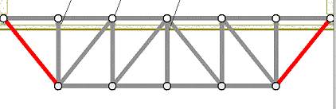

- Bridge must have a width of 11cm (length of craft stick)
- Maximum depth below top of roadway 6cm
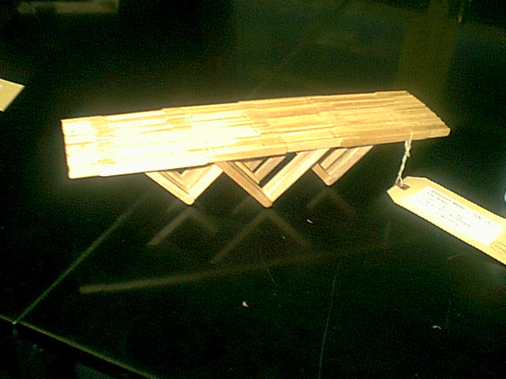
RULES FOR CONSTRUCTION:
- A maximum of 50% of a craft stick’s total flat surface may be glued. Both sides of each stick can be considered in the 50% calculation. e.g. 100% of side 1 and 0% of side 2; 75% of side 1 and 25% of side 2. Glue must only be used at joints, and must not be used on the surface of the roadway.
- The bridge must have a flat surface to accommodate testing apparatus and the bridge may not have a roof, covering or any other object that will interfere with the 10cm diameter plate that is placed directly on roadway at midspan to apply the force for load bearing capacity.
- I-beams are illegal.
- T-sections and longitudinal glue may be used on the roadway only.

Wrap-up
After completing their first prototype, areas for improvement to continue refining design can be discussed with students. Consider the following questions:

- Where does your bridge fail under excessive load?
- How can you construct a bridge capable of supporting your weight?

Lesson Background for Teachers

Suggested Real-World STEM Connections
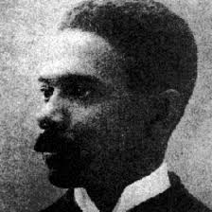
Frederick Blackburn Pelham was the first African-American to receive an engineering degree from the University of Michigan. An excellent student who would become president of his graduating class, Pelham earned a bachelors of science degree in civil engineering in 1887 and immediately began a career in bridge design and construction with the Michigan Central Railroad.
In his brief but highly productive career as a civil engineer, Pelham became known for designing bridges that were built to last – though this was less true, unfortunately, of Pelham, who died at home in 1895, reportedly of acute pneumonia, at the tender age of 30 years old.
Among the more famous and unusual of Pelham’s creations is the so-called “skew arch” bridge located in Dexter, Michigan, just northwest of Ann Arbor – though there’s a more impressive Pelham-designed bridge, also within the Dexter city limits, whose much higher arch spans Mill Creek.
The skew arch (a design used when bridges are not perpendicular to crossings) passes over Dexter-Pinckney Road at the northwest edge of town, where it has received a great deal more attention because drivers tend to have to slow down to navigate its narrow, one-lane opening. The bridge originally accommodated pedestrians and horse-drawn buggies – and then a few automobiles. But once traffic increased, officials posted extensive signage to warn motorists of its mere 11 feet, 10 inch clearance.
Before constructing its elegant stone arch, a temporary wooden frame was installed under the rail bed. The soil the laborers had dug out was then used to raise the banks and straighten out Mill Creek as protection for the new bridge. Masons collected stones for both bridges and sized them by hand, and onlookers were said to be impressed by the strength of the bridge and the perfect fit of the stones that Pelham and the other workers had carved and used. For many years Michigan Engineering students would make field trips to visit the bridge and study its skew arch.

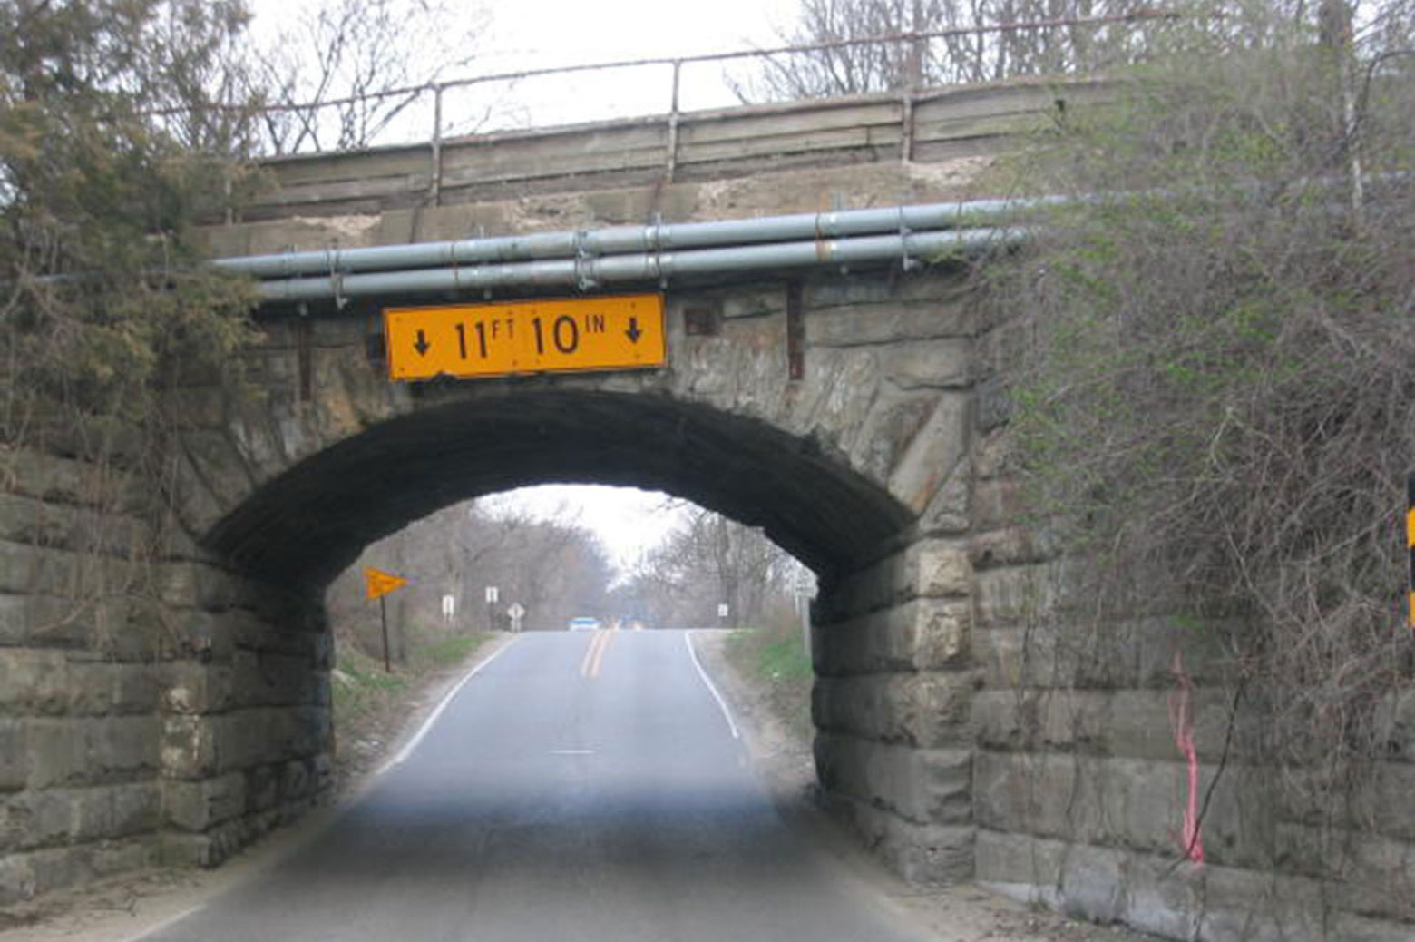
Dexter, Michigan "skew arch" bridge designed by Fred B. Pelham. Photo courtesy Historic Bridges.

Lesson Variations and Options
- Students can use uncooked spaghetti instead of popsicle sticks.

Explanation
There are various types of bridges, such as suspension bridges and arch bridges. The choice of bridge type depends on several factors, including budget, the terrain where the bridge will be built, its intended use, and the materials available.
Regardless of the type, a truss is a solid and economical construction method. A truss consists of straight bars arranged into triangles. When three bars form a triangle, the shape is stable and cannot be altered, making trusses very robust. In contrast, four bars forming a square can still be pressed together despite being connected. In a truss, the nodes (where the bars connect) act like hinges, meaning each bar only experiences compression or tension forces—forces that either shorten or stretch them lengthwise. There are no forces causing the bars to bend.
Deformation in technology and engineering refers to a change in the size or shape of an object when subjected to a force or a change in temperature. In this context, the bridge deforms under a pushing force, such as a heavy load placed on it. The deformation occurs as the wood (primarily lignin and cellulose)changes shape or breaks apart. The bridge can endure a certain amount of deformation without breaking, but if the load is too heavy, a popsicle stick or node will break.

Key Concepts and Vocabulary
- Truss Bridge: A truss bridge is a bridge with a load-bearing structure made of a truss, which is a series of connected elements that usually form triangles.
- Suspension Bridge: bridge with overhead cables supporting its roadway. Modern suspension bridges are light and aesthetically pleasing and can span longer distances than any other bridge form. They are also among the most expensive bridges to construct. Though suspension bridges can be made strong enough to support freight trains, they have nearly all been designed for automobile traffic.
- Arch bridge:This bridge has a main structure made of arches or reinforced arches that curve upward to support vertical loads. The bridge's weight and other loads are transferred into a horizontal thrust that is restrained by abutments on either side.
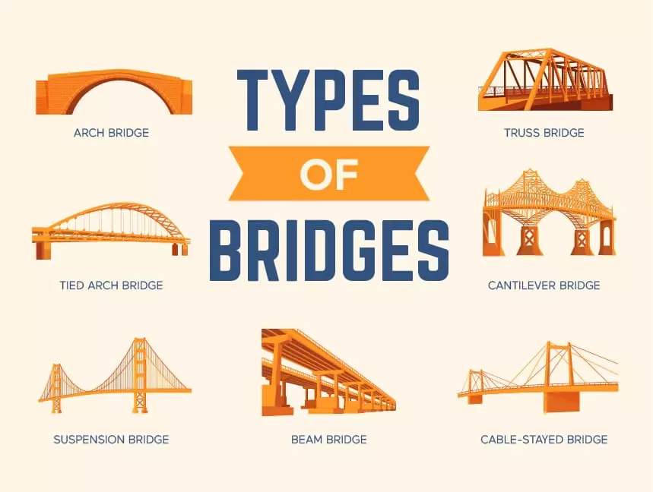

Safety Notes
- Students should carefully and cautiously use the scissors and other cutting tools.

